# Bahria University,

## Karachi Campus



COURSE: SEL-448

Artificial Intelligence Lab

TERM: SPRING 2024, CLASS: BSE- 6(B)

Submitted By:

Muhammad Shoaib Akhter Qadri_____________79290___

(Name) (Reg. No.)

Submitted To:

Engr. Hamza / Engr. Faiz ul Haq

Signed Remarks: Score:__

INDEX

|  |  |  |  |  |
| --- | --- | --- | --- | --- |
| SNO | DATE | LAB NO | LAB OBJECTIVE | SIGN |
| 01 | 14/02 | 01 | Basic to Advance Python |  |
|  |  |  |  |  |
|  |  |  |  |  |
|  |  |  |  |  |
|  |  |  |  |  |
|  |  |  |  |  |
|  |  |  |  |  |
|  |  |  |  |  |
|  |  |  |  |  |
|  |  |  |  |  |
|  |  |  |  |  |
|  |  |  |  |  |

# Bahria University,

## Karachi Campus



LAB EXPERIMENT NO.

**_01_**

LIST OF TASKS

|  |  |
| --- | --- |
| **TASK NO** | **OBJECTIVE** |
| 01 | Create a simple calculator program that can perform basic arithmetic operations like addition, subtraction, multiplication, and division. |
| 02 | Write a program that generates a random number and asks the user to guess it. Provide hints such as "too high" or "too low" until the user guesses the correct number. |
| 03 | Write a program that checks if a given string is a palindrome (reads the same forwards and backwards). |
| 04 | Create a program that counts the frequency of words in a given text file or input string. |
| 05 | Write a program that prints the numbers from 1 to 100. But for multiples of three, print "Fizz" instead of the number, and for the multiples of five, print "Buzz". For numbers that are multiples of both three and five, print "Fizz Buzz". |
| 06 | Create a program that converts temperatures between Celsius and Fahrenheit. |
| 07 | Implement the classic game of Hangman where the user has to guess a word by suggesting letters within a certain number of attempts. |
| 08 | Write a program that reads data from a text file, performs some operation (e.g., sorting, filtering), and writes the result to another file. |

Submitted On:

Date: 15/02/2024

**Task No 01:** Create a simple calculator program that can perform basic arithmetic operations like addition, subtraction, multiplication, and division.

**Solution:**

def add(x, y):

    return x + y

def subtract(x, y):

    return x - y

def multiply(x, y):

    return x * y

def divide(x, y):

    return x / y

print("Please choose an operation:")

print("1. Add")

print("2. Subtract")

print("3. Multiply")

print("4. Divide")

choice = input("Enter your choice (1/2/3/4): ")

num1 = float(input("Enter the first number: "))

num2 = float(input("Enter the second number: "))

if choice == '1':

    result = add(num1, num2)

    print(f"{num1} + {num2} = {result}")

elif choice == '2':

    result = subtract(num1, num2)

    print(f"{num1} - {num2} = {result}")

elif choice == '3':

    result = multiply(num1, num2)

    print(f"{num1} * {num2} = {result}")

elif choice == '4':

    result = divide(num1, num2)

    print(f"{num1} / {num2} = {result}")

else:

    print("Invalid choice")

**Output:**

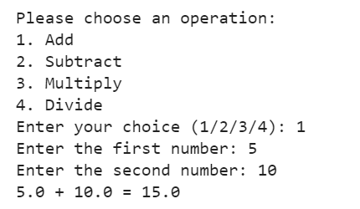

**Task No 02:** Write a program that generates a random number and asks the user to guess it. Provide hints such as "too high" or "too low" until the user guesses the correct number.

**Solution:**

import random

number = random.randint(1, 100)

guesses = 0

while True:

    guess = int(input("Enter your guess: "))

    guesses += 1

    if guess == number:

        print(f"You guessed it in {guesses} tries!")

        break

    elif guess > number:

        print("Too high. Try again.")

    else:

        print("Too low. Try again.")

**Output:**

**Task No 03:** Write a program that checks if a given string is a palindrome (reads the same forwards and backwards).

**Solution:**

def is_palindrome(string):

    string = string.lower()

    reversed_string = string[::-1]

    return string == reversed_string

string = input("Enter a string: ")

if is_palindrome(string):

    print(f"{string} is a palindrome.")

else:

    print(f"{string} is not a palindrome.")

**Output:**

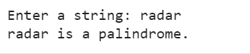

**Task No 04:** Create a program that counts the frequency of words in a given text file or input string.

**Solution:**

def word_frequency(text):

    words = text.split()

    word_count = {}

    for word in words:

        if word in word_count:

            word_count[word] += 1

        else:

            word_count[word] = 1

    return word_count

# Test the function

text = "Shoaib Akhter Qadri"

print(word_frequency(text))

**Output:**



**Task No 05:** Write a program that prints the numbers from 1 to 100. But for multiples of three, print "Fizz" instead of the number, and for the multiples of five, print "Buzz". For numbers that are multiples of both three and five, print "Fizz Buzz".

**Solution:**

for i in range(1, 101):

    if i % 3 == 0 and i % 5 == 0:

        print("Fizz Buzz")

    elif i % 3 == 0:

        print("Fizz")

    elif i % 5 == 0:

        print("Buzz")

    else:

        print(i)

**Output:**

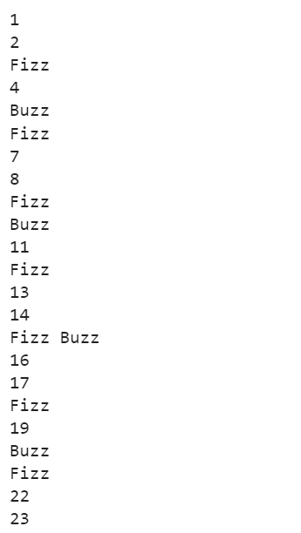

**Task No 06:** Create a program that converts temperatures between Celsius and Fahrenheit.

**Solution:**

def celsius_to_fahrenheit(celsius):

    return (celsius * 9/5) + 32

def fahrenheit_to_celsius(fahrenheit):

    return (fahrenheit - 32) * 5/9

# Test the functions

celsius_value = 30

print(f"{celsius_value} Celsius is equal to {celsius_to_fahrenheit(celsius_value)} Fahrenheit")

fahrenheit_value = 86

print(f"{fahrenheit_value} Fahrenheit is equal to {fahrenheit_to_celsius(fahrenheit_value)} Celsius")

**Output:**

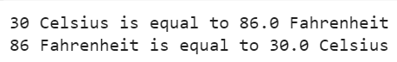

**Task No 07:** Implement the classic game of Hangman where the user has to guess a word by suggesting letters within a certain number of attempts.

**Solution:**

import random

def hangman():

    words = ['python', 'java', 'ruby', 'javascript', 'html', 'css']

    word = random.choice(words)

    guessed_letters = []

    attempts = 6

    while attempts > 0:

        word_completion = ""

        for letter in word:

            if letter in guessed_letters:

                word_completion += letter

            else:

                word_completion += "_"

        print(word_completion)

        if word_completion == word:

            print("Congratulations! You've guessed the word.")

            break

        guess = input("Guess a letter: ").lower()

        guessed_letters.append(guess)

        if guess not in word:

            attempts -= 1

            print(f"Sorry, {guess} is not in the word. You have {attempts} attempts left.")

    else:

        print(f"Sorry, you've run out of attempts. The word was {word}.")

hangman()

**Output:**

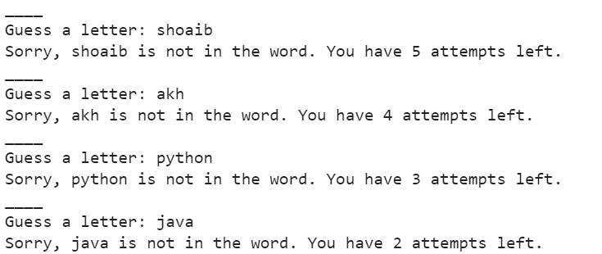

**Task No 08:** Write a program that reads data from a text file, performs some operation (e.g., sorting, filtering), and writes the result to another file.

**Solution:**

def file_operation(input_file, output_file):

    with open(input_file, 'r') as file:

        data = file.read()

        # Perform some operation on the data (e.g., sorting, filtering)

        processed_data = data.upper()

    with open(output_file, 'w') as file:

        file.write(processed_data)

# Test the function

file_operation('input.txt', 'output.txt')

**Output:**

